Chinese New Year Festival 2024
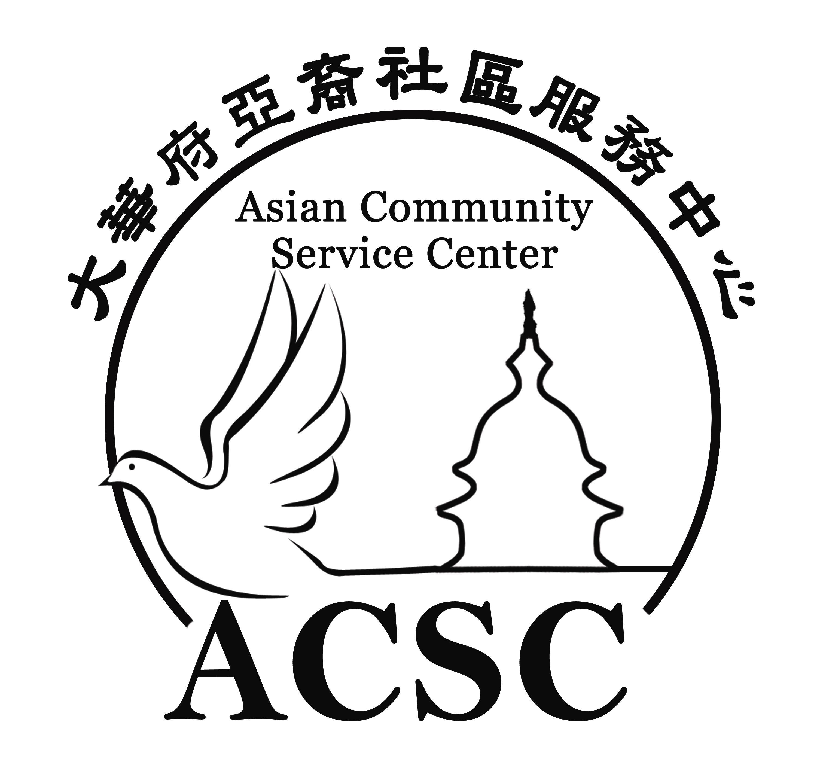

www.ChineseNewYearFestival.org

Sponsorship

Date: Saturday, February 17, 2024
Hours: 10am to 6pm
Location: Luther Jackson Middle School
3020 Gallows Road
Falls Church, VA 22042

Asian Community Service Center
2758 Stone Hollow Dr.
Vienna, VA 22180
Tel:703-868-1509
Fax:703-763-2340
Email: Contact@AsianServiceCenter.org

About the event
Chinese New Year (the Lunar New Year) is the most important of the traditional holidays celebrated by Asian Americans such as Chinese, Korean, Vietnamese, Mongolian, etc.
The Asian Community Service Center would like to extend this holiday mood from Asian communities to all in the metropolitan area. The Festival will add cultural flavor to this dynamic international city and promoting multi-cultural exchanges through artistic performances, art crafts and food.

Marketing Plan
- Advertisements on Chinese and English newspapers starting from Dec. 2022
- Information to be disseminated by online video
- High-quality postcards to be distributed in community public venues
- Public relations efforts – event listing on newspaper community calendars and online event calendars
- Social media

Sections
Performance stage
Art crafts
Food
Non-Profit
Business/Corporation
Kids play zone

Benefit of the Event
- Promote your business by making connections to the Asian and local communities
- Enhance the brand image of your products/services
- Display your products/services to the audience of the event

Price Range: $600-$20,000

Sponsorship Benefits:
A--One booth space 8’x10’
B--One booth space 16’x10’
C-- Name/Logo on promotion Postcards
D--Name/Logo/Link on Chinese New Year Festival website
E--Banner right for one of the sections (stage, business expo, food court, kids zone)
F-- Advertisement in Event Publication (full, 1/2, 1/4, 1/8 or 1/16 page)
G-- Greeting ads in the Vision Times newspaper Chinese version (full, 1/2, 1/4, 1/8 or 1/16 page)
H---Opportunity to be introduced at stage

Diamond Sponsor: $600
A, D, F(1/16 page)

Lucky Bird Sponsor: $1,000
A, C, D, F(1/8 page)

Tiger Sponsor: $2,500
A, C, D, E(one section), F(1/2), G(1/4 page),

Lion Sponsor: $5,000
B, C, D, E (two section), F(full page), G(1/2 page),

Golden Eagle Sponsor: $10,000
B, C, D, E(three section), F(full page), G (full page ), H

Signature Sponsor: $20, 000
B, C, D, E(all the sections), F(full page), G (full page), H, Signature

